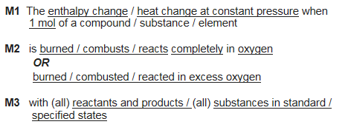
Suggest why calculations using mean bond enthalpies sometimes give different values to calorimetry experiments
Heat loss
Mean bond enthalpies are an average over a range of compounds
The enthalpy change which occurs when one mole of covalent bonds is broken, averaged over a range of different compounds
Suggest one improvement that could be made to a calorimetry experiment to reduce heat loss.
