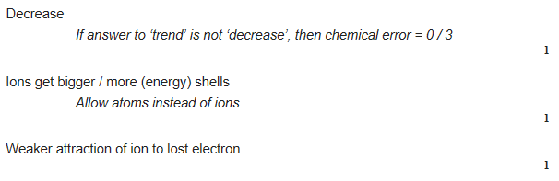
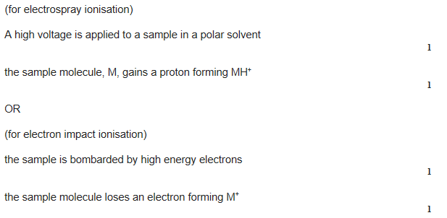
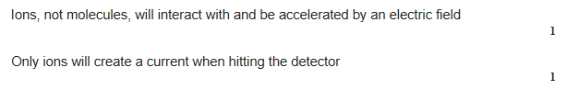
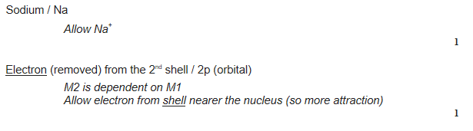
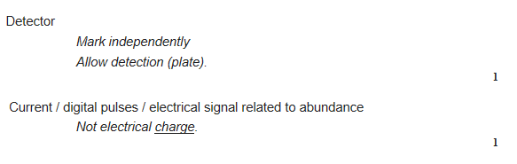
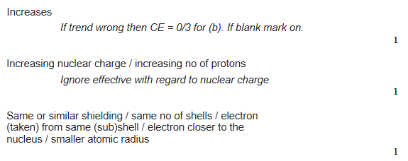
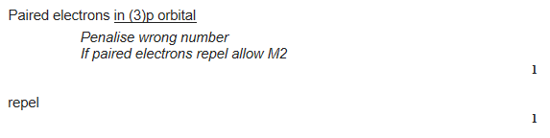
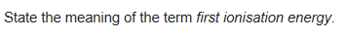
Energy needed to remove one mole of electrons from one mole of gaseous atoms
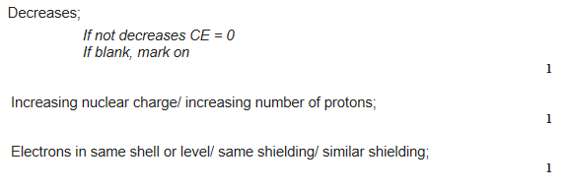
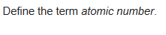
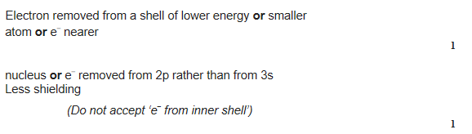
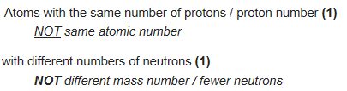
Explain why aluminium has a lower first ionisation energy than would be expected by the general trend
