Causes another species to lose electrons
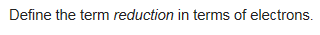
Loss of electrons

