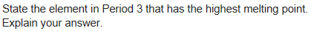
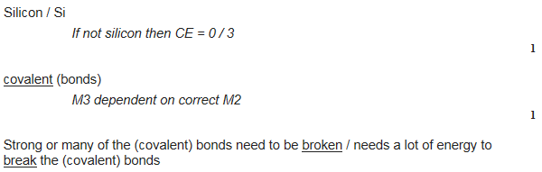
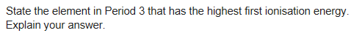
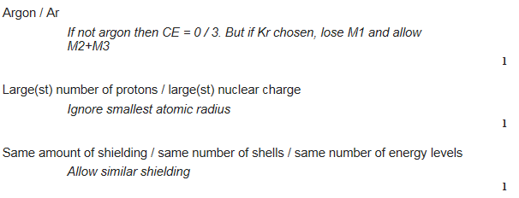
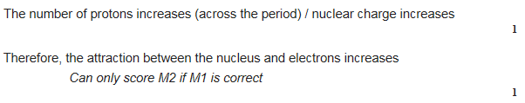
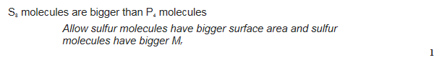
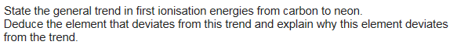
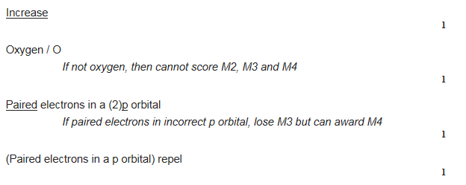
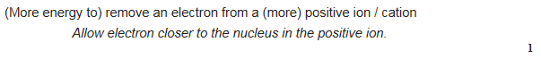
Al has a higher charge (+3) than sodium (+1)
More delocalised electrons
Stronger metallic bonding
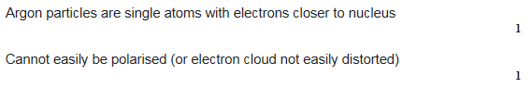
Why does Aluminium not follow the general trend in first ionisatipn energies across the period?
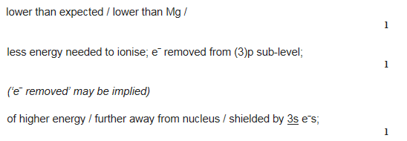
Why would an element be classed as a p-block element?
The outer electron is in a p orbital
Why would an element be classed as a s-block element?
The outer electron is in a s orbital
Why would an element be classed as a d-block element?
The outer electron is in a d orbital

