State why the Maxwell Boltzmann curve goes through (0,0)
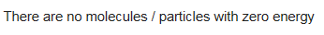
With reference to the Maxwell-Boltzmann distribution, explain why a decrease in temperature decreases the rate of reaction
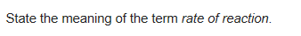
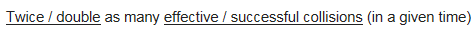
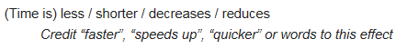
None
Collision between the reactant particles
With the activation energy
A small increase in temperature results in many more molecules having energy greater than the activation energy
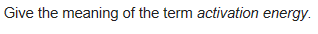
The minimum energy for a reaction to occur
Explain the process that causes some molecules to have very low energies
Collisions cause some molecules to slow down/lose energy
Suggest a reason why a solid catalyst is often in the form of a powder.
In terms of the behaviour of particles, explain why the rate of reaction decreases with time
Fewer collisions as there are less reactant particles
What does the area under s Maxwell-Boltzmann curve represent?
The total number of particles

