Q1.This question is about the Maxwell–Boltzmann distribution of molecular energies in a sample of a gas shown in the figure below.
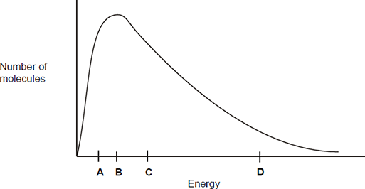
Which letter best represents the mean energy of the molecules?

A
B
C
D

(Total 1 mark)

Q2.This question is about the Maxwell–Boltzmann distribution of molecular energies in a sample of a gas shown in the following figure.
What does the area under the curve represent?

 | A | The total energy of the particles.
 | B | The total number of particles.
 | C | The number of particles that can react with each other.
 | D | The total number of particles that have activation energy.

(Total 1 mark)

Q3.The apparatus in the figure below was set up to measure the time taken for 20.0 cm³ of sodium thiosulfate solution to react with 5.0 cm³ of hydrochloric acid in a 100 cm³ conical flask at 20 °C. The timer was started when the sodium thiosulfate solution was added to the acid in the flask. The timer was stopped when it was no longer possible to see the cross on the paper.
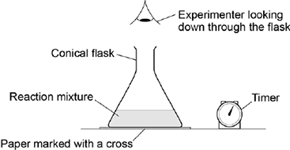
What is likely to decrease the accuracy of the experiment?

 | A | Rinsing the flask with acid before each new experiment.
 | B | Stirring the solution throughout each experiment.
 | C | Using the same piece of paper for each experiment.
 | D | Using different measuring cylinders to measure the volumes of acid and sodium thiosulfate.

(Total 1 mark)

Q4.The experiment was repeated at 20 °C using a 250 cm³ conical flask.
Which statement is correct about the time taken for the cross to disappear when using the larger conical flask?

 | A | The time taken will not be affected by using the larger conical flask.
 | B | The time taken will be decreased by using the larger conical flask.
 | C | The time taken will be increased by using the larger conical flask.
 | D | It is impossible to predict how the time taken will be affected by using the larger conical flask.

(Total 1 mark)

Q5.This question is about the reaction given below.
CO(g) + H₂O(g) CO₂(g) + H₂(g)
Enthalpy data for the reacting species are given in the table below.

 | Substance | CO(g) | H₂O(g) | CO₂(g) | H₂(g)
 | ΔH / kJ mol⁻¹ | −110 | −242 | −394 | 0

Which one of the following statements is not correct?
A The value of K_{p} changes when the temperature changes.
B The activation energy decreases when the temperature is increased.
C The entropy change is more positive when the water is liquid rather than gaseous.
D The enthalpy change is more positive when the water is liquid rather than gaseous.
(Total 1 mark)

Q6.The compound lithium tetrahydridoaluminate(III), LiAlH₄, is a useful reducing agent. It behaves in a similar fashion to NaBH₄. Carbonyl compounds and carboxylic acids are reduced to alcohols. However, LiAlH₄ also reduces water in a violent reaction so that it must be used in an organic solvent.
Which one of the following concerning the violent reaction between LiAlH₄ and water is false?
A A gas is produced.
B The activation energy for the reaction is relatively high.
C The reaction has a negative free-energy change.
D Aqueous lithium ions are formed.
(Total 1 mark)

Q7.
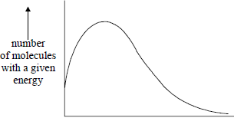
energy
The total area under the distribution curve represents
A total energy.
B activation energy.
C total number of reacting molecules.
D total number of molecules present.
(Total 1 mark)

M1.C
[1]

M2.B
[1]

M3.A
[1]

M4.C
[1]

M5.B
[1]

M6.B
[1]

M7.D
[1]

